A newsletter for Parish Councils from the Borough Councillors of the Mid-Test Ward
Mid-Test Matters
Issue 14 1st August 2020
Community Infrastructure Levy (CIL)
Test Valley Borough Council will be running an additional round of the CIL Spending Protocol this year. Accepting bids for funding between 1st September and 30th November 2020. This is our third year of running the process. The first two resulted in 14 successful bids being awarded a total of £1,100,000. An example of a successful bid was the Kings Somborne’s Community Building and Preschool.
Bidding documents and guidance are available on the TVBC website at https://testvalley.gov.uk/planning-and-building/cil/bidding-for-cil-funds

Stockbridge safety for pedestrians
Stockbridge Parish Council have launched a project to install protective barriers in key areas of the High Street providing more room for pedestrians where its needed. This is being done with the minimum possible impact on parking. Given the importance on safety the Parish Council are funding the initial phase of the project but hope to obtain grant funding to cover a longer period of time.
Major new campaign encourages millions to lose weight and cut COVID-19 risk
An absolute must to come out of the pandemic has got to be a national effort to reduce risk of dying from this any future virus. A new national campaign is under way to encourage millions of adults to kick start their health and reduce their risk of serious illness, including COVID-19. The campaign – unveiled as part of the government’s new Obesity Strategy – encourages adults to introduce changes that will help them work towards a healthier weight, with a suite of free tools and apps supporting people to eat better, drink less alcohol and get active.
Announcement: https://www.gov.uk/government/news/major-new-campaign-encourages-millions-to-lose-weight-and-cut-covid-19-risk

Most comprehensive flu programme in UK history will be rolled out this winter
The most comprehensive flu vaccination programme in the UK’s history was announced by the government on Friday (24 July). A significant new group will be eligible for the free flu vaccine as people aged 50 to 64 will be invited later in the season for a vaccination. Providers will work to vaccinate more than 30 million people during this flu season – millions more than received it last year.
Announcement: https://www.gov.uk/government/news/most-comprehensive-flu-programme-in-uk-history-will-be-rolled-out-this-winter
We await details from our local surgeries on the timing and locations for Mid Test.
On the subject of surgeries, the volunteer delivery service of prescriptions is due to finish at the end of this week.
Current Covid-19 grant schemes
The government has announced that the current small business, retail and discretionary grant schemes are to come to an end as of August 28.
TVBC Officers are currently in the middle of the second round of applications and will be able to offer an update in a couple of weeks' time after these have all been processed.
Household Waste Recycling Centres (HWRCs)
Andrew Gibson will probably put this item in his brief but it quite important for users of the recycling centres so we have included it here.
Hampshire County Council is reminding residents who have not yet registered for the free entry system which will be managed using Automatic Number Plate Recognition (ANPR) at Hampshire HWRCs, to do so. The system will ensure continued free access for Hampshire residents to any of Hampshire’s 24 HWRCs to dispose of household waste, while access for non-Hampshire residents (excluding Dorset Council residents) will be for a fee of £5 per visit. Up to three cars per Hampshire household can be registered for continued free access to Hampshire HWRCs using an online form. Nearly 389,000 households have already successfully registered.

The ANPR registration scheme, which is being introduced on 1 August, was originally intended to begin on 1 April, but HWRCs were closed at the end of March following Government advice on essential travel.
Residents are also reminded that due to the Covid-safety measures in place, they will still have to book a slot before visiting an HWRC - using the online booking system or by phoning 02380 179 949, Monday to Friday 9am to 5:30pm.

Adventure Golf at Charlton Lakes
Charlton Lakeside is set to benefit from a new adventure golf course as part of the upgrading of our leisure facilities by Places Leisure. The old facility was well-used but is long past its best. It will now be removed completely and replaced with a new Iron Age-themed course in a nod to the area’s history. It will represent a major upgrade of the site.
Places Leisure had previously submitted plans for a high ropes course at the site. However, due to concerns from local people and environmental health the new adventure golf scheme was put forward as an alternative, which will help transform the site. The new scheme was granted planning permission last week.

Stockbridge Local Recycling Centre
In May 2019, we installed a temporary local recycling centre (LRC) at Roman Road in Stockbridge, close to the Test Valley School. We were fortunate to find this location as the previous LRC had to be removed from the White Hart Pub due to building works.
Unfortunately, this week we have been requested to remove the site. As we have not yet found an alternative location in Stockbridge, the area will be without glass recycling facilities. The nearest LRCs are at West Down in Chilbolton and at Kings Somborne.
Notices have been placed on the Roman Road banks, and they will be removed on Wednesday 29 July. Information has also been shared on our social media pages.

Test Valley Borough Council Grant Funding
Quite rightly Parish Councils have been focusing on seeking Covid -19 funding to help them through these difficult times. As things slowly begin to return to the new normal there will be opportunities to explore new community projects. We have included a reminder of The Councillors Community Grant Scheme.

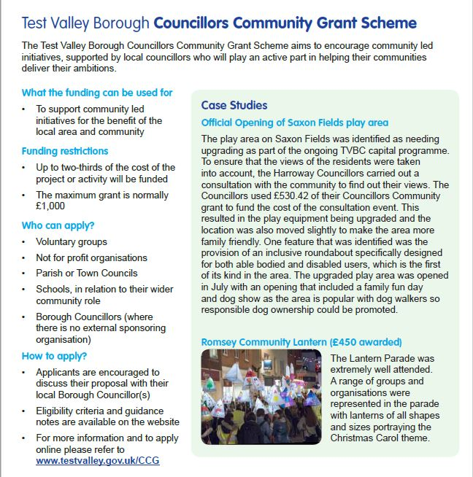
Staying in Contact
We continue to have meetings via telephone or video conferencing where we can and we are all adapting to these new ways of working. If you need to speak to Borough councillors outside of these meetings, our contact details are below

Our Contact Details
Councillor Ian Jeffrey cllrijeffrey@testvalley.gov.uk 01794 388872
Councillor Alison Johnston cllrajohnston@testvalley.gov.uk 01794 500610
Councillor Tony Ward cllrtward@testvalley.gov.uk 01794 389649

