NWPC - CLERK’S REPORT & CORRESPONDENCE RECEIVED.
September 14th 2020

CLERK’S REPORT | DECISION REQUIRED | ACTION TO BE TAKEN.
- The separate accounts with Business Stream (playing fields, Village Green and Village Hall) have been merged into one account and are now viewable online. Three payments have been set up for 15th Sept 2020. | NO | NONE
- Safer Cycling and Walking Scheme, John Harvey at HCC was contacted with the suggestions from the Working Group, however he declined to reply until after the deadline for the funding had passed. | NO | Working group to reconvene w/c 21st September.
- Defibrillator has been ordered from the British Heart Foundation. The NW Social Club Charity have agreed to pay for the outdoor cabinet and have it fitted. | NO | Clerk progressing.
- The container for the mower for the Green has been ordered and paid for. It is scheduled for delivery on Thursday 24th September. The Chairman of the VGWG will be in attendance. | NO | Clerk progressing.

CORRESPONDENCE RECEIVED | DECISION REQUIRED | ACTION TO BE TAKEN.
- A resident has requested that permission be given to hold a Coffee/Cake Stall on the Village Green on 26th September 10.00-12.00. | YES | Approve Risk Assessment  Confirm signage provisions.
- A resident has written to council regarding the grass at the playing fields which he has said is always well cut with the exception of the grass around the pavilion which is very long and often contains litter. | YES | Agenda for next month?
- An agent for a landowner has enquired if there had been progression on the NDP. They had been referred to the council website section showing the minutes for the steering group and had been sent a copy of the advert for the public consultation on 28th August. | NO | Clerk has responded.
- A resident enquired if a response had been received from HCC in relation to the parking and verge encroachment in Five Bells Lane. A link to the news section of the PC website had been provided showing the response from HCC: “Further to our previous communication regarding the verge outside Thornley House, the matter was referred to the Highways Manager. After careful consideration and discussion with the senior manager, whilst there appears to be a small encroachment, there doesn't appear sufficient verge encroachment overlaying the carriageway surface or risk to undertake enforcement action. The original boundary remains highway and therefore may be re-established by future maintenance or vehicular overrun. kind regards, Highways Support Officer” | NO | Clerk has responded.
- A resident has asked if the steep style at the back of Ringwold House could have a couple of concrete blocks inserted at each end to aid climbing over. | NO | This has been passed to the Over Wallop Clerk to look into as the area is part of OW Parish.
- It was also mentioned that the footpath in Bent Street has branches overhanging the wall from Hill Farm House and these were at head height. The footpaths officer would investigate. | NO | The NWFootpath officer has checked and there is plenty of room (about a metre) of space to walk around the branches which are laden with fruit.  The branches will be cut back after the growing season .
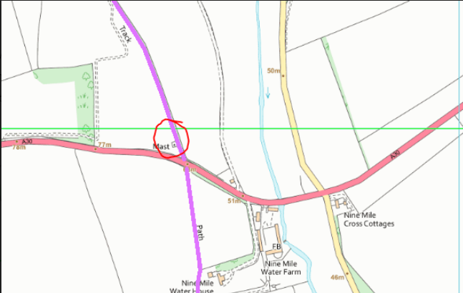  - A landowner has advised that some changes have been proposed to an existing mobile phone mast which abuts a right of way near the A30 at Nine Mile. The mast operator (Cellnex) is seeking to upgrade the mobile phone mast which lies to the north of the A30 and Nine Mile Water farm buildings. The upgrade will include 5G in the future. | YES | Decide on actions to take.  Publicise?  Register comments with planning?
- A landowner has written regarding the proposal that part of his property be designated a Green Space in the NDP. His query has been forwarded to the NDP Steering Group who will consider the request at their next meeting. In the meantime, the resident has been sent a copy of the FAQ on Green Spaces that was provided for the public consultation on 28th August. | NO | Clerk to add correspondence to NDP SG Agenda.
- The Rural Community Energy Fund has written to council:  There is an opportunity for local Councils and community groups who are interested in installing renewable energy technologies to apply for up to £40,000 to cover the cost of a feasibility study from a professional consultant. Both the South East and South West Energy Hubs are available to provide support to help you make a successful application. The eligible technologies are:  - Solar photovoltaic  - Solar thermal  - Anaerobic digestion  - Wind turbines  - Multi-technology approaches  - Heat pumps (air, ground and water-source)  - heat networks (renewable fuels only)  - Hydropower  - Bioliquids/gas/fuels  In addition to Town and Parish Councils, these types of community groups can also apply:  - Community Interest Companies (CICs)  - Community Benefit Societies (Bencoms)  - Co-operatives  - Pre-commencement societies  - Registered Social Landlords  - Charitable Incorporated Organisations (CIOs)  - Registered Charities  - Development Trusts  - Amateur sports associations  - Town or Parish councils  https://www.energyhub.org.uk/rural-community-energy-fund/introduction/ | YES | Councillors to decide on action to take.
- TVBC have advise that a new road name sign has been ordered for installation in Wallop Drove to replace the sign discarded in the hedgerow. | NO | TVBC have responded.
- A landowner has written asking if there is interest in a triangle of land next to the Church being given to the Parish/Church to aid car parking at the Church. | NO | Clerk has advised the PCC and will revert with comments for the next agenda.

