Mid-Test Matters
Issue 28 02 November 2021
A newsletter from the Borough Councillors of the Mid-Test Ward
Joint recycling strategy given approval by cabinet
A joint recycling strategy across Hampshire has been approved by Test Valley borough council’s cabinet, putting into action a number of positive changes to recycling collections around the borough.
It is now likely that following the government’s current Environment Bill, glass, thin plastics and Tetra Pak materials can all be included in TVBC recycling bins at the kerbside in the future. And, in addition, it’s anticipated that the council will also be able to offer a weekly food waste service.
The council has been part of Project Integra since its creation in 1995, together with other district councils in the county. Now, those same councils, including TVBC, have approved the changes that will see these major changes to recycling over the coming years through the Joint Municipal Waste Management Strategy.
Currently, the council is limited as to what it can recycle due to what can go through the Hampshire facilities that the borough’s recycling is sent after it is collected. However, the Environment Bill 2020 has seen central government targeting an increase in recycling rates, meaning these facilities will be the focus of improvements, enabling these changes.
One of the key areas of focus in the strategy includes implementing a ‘twin-stream’ recycling system, key to giving the County Council the certainty it requires to invest in its waste infrastructure.
Councillor Phil North, who is TVBC’s Project Integra representative, said: “I’m very pleased to have been able to approve this vital management strategy at cabinet recently, which puts into gear the sizeable changes that will give our residents more opportunities to recycle. Although less than six per cent of waste here in Test Valley goes to landfill, we can’t stop striving to do more, and reduce that number even more.”
Environmental portfolio holder, councillor Alison Johnston, added: “I know I speak for everyone in Test Valley when I welcome these changes locally, and for the county as a whole. There’s plenty of work for us to undertake to get these changes in place, but there’s no better cause than ensuring we recycle more, continue to battle climate change and make our borough more environmentally-friendly.”


New green space for communities to enjoy

Communities will be able to enjoy a new wildlife-rich area of countryside in the future as Test Valley Borough Council is in the process of purchasing land near Upper Clatford for the public to use.
Situated to the south of Bury Hill, the land is currently used for agriculture, and covers around 38 acres.
The council recently exchanged contracts with the owner and will buy the plot using money secured from developer contributions to help improve access to the countryside.
Once the council completes the purchase towards the end of 2021, it will begin working towards opening up the space for the public to enjoy, with the aim of making it available for use in autumn 2022.
It is also planning to plant around 7.5k trees at the site, adding to the 11k it will be planting this autumn and winter across the borough.
TVBC leader, councillor Phil North, said: “The Covid-19 pandemic highlighted just how important green space is to our communities. My hope is that generations to come can enjoy this wonderful area of countryside and make the most of what the borough has to offer.
“Our planet has to be at the forefront of our minds, and of course this will be the primary topic of conversation over the coming weeks as we head towards the UN Climate Change Conference, Cop26, in Glasgow. In Test Valley, we are doing all we can to support these international efforts to reduce our carbon output, open up more green space such as this, and work together to fight climate change.”
The news comes as Phil North announced earlier this week that he would be creating a new portfolio focusing on climate change and countryside, which will be headed up by councillor Alison Johnston.
Councillor Johnston added: “This will be a wonderful space for local communities to enjoy and wildlife to flourish. And with great environmental benefits to boot, this is fantastic news for all.”

Plans in place for next steps in Local Plan
The timeline for putting together one of the borough’s most important planning documents has been agreed as Test Valley Borough Council gears up for public consultation early next year.
The Local Plan sets out the policies and guidelines for planning up and down the borough, and helps to look after the environment while making provision for the facilities and services that the community needs.
Now, the next step in putting this plan together has been agreed, with a timeline now in place for the council to follow, and to consult with the public.
An updated Local Development Scheme has been approved by the authority’s cabinet which outlines the timeline, with this next stage being undertaken in two stages.
Early next year, the public will be asked to have their say on the Local Plan’s vision and objectives, housing and economic needs and how it supports our town centres, delivering masterplans for both Andover and Romsey.
Other areas for consideration include the overall scale and broad strategy for the distribution of growth and the delivery of sustainability and design.
Then, later in 2022, a consultation will be launched with the public on the full draft plan which will have taken into account the first stage’s responses. Settlement boundaries and site allocations for housing and commercial development will also be open for discussion during this phase.
Thermal Imaging Workshop has moved to an online event

Would you like help to reduce your heating bills this winter?
A thermal-imaging camera is an amazing device as it can detect the temperature of everything. It’s able to show us where heat is escaping from our homes and our buildings. Often the camera reveals that heat is leaking out through draughty windows or badly-fitting doors, or through a roof without enough insulation. By tackling these problems, you can achieve significant savings on your winter heating bills.
You will find out how to use the camera and how to survey your home or community building during this event.
Please note this event is now online only and booking is essential.

To book a place visit Free Thermal Imaging Workshop Tickets, Thu 4 Nov 2021 at 19:00 | Eventbrite This is a free workshop for town and village parish councils, community groups and local residents.
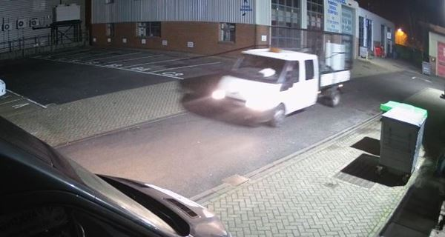

Fines for scrap metal dealers dumping waste in industrial estate

Two unlicensed scrap metal dealers have been prosecuted by Test Valley Borough Council after dumping household rubbish at Romsey’s Abbey Park Industrial Estate in the middle of the night.
They operated as a partnership, advertising scrap metal collection and disposing of other waste.

However, they were caught in December last year entering the industrial estate just after midnight, searching commercial bins, removing items and making a number of trips to deposit other waste within them.

The waste included duvets, clothes, DVD cases and other household items. Despite their advertising of their services, the company was operating without a scrap metal dealer’s licence.

Following council enquiries to the local scrap metal yard showed that even without a licence, they had visited regularly, receiving more than £40,000 during the pandemic between March 2020 and the same month in 2021.

Despite this, the defence stated that due to the market, there was a sizeable drop in the money being earnt.

One admitted fly-tipping and was fined £800, made to pay £225 costs and an £80 victim surcharge. The other man also admitted fly-tipping and operating without a scrap metal dealer’s licence. He was fined £1,300, ordered to pay £225 costs and an £80 victim surcharge.

Environmental portfolio holder, councillor Alison Johnston, said: “This is a deliberate, negligent act where two people, operating as a company, entered an industrial estate in the middle of the night, and simply dumped their waste that they had been paid to collect.

“I’m pleased that they had their day in court facing up to what they have done, and hopefully now they will learn that there is a zero-tolerance approach to fly-tipping. Anyone who is using a waste carrier should check that they are licensed to do so, via the environment agency website.

Hundreds of pounds for Happy Meal after littering fine

An Andover woman had an expensive Happy Meal after she was caught in the act by a councillor, dumping her fast-food rubbish in a disabled car parking spot.
Test Valley Borough Council prosecuted the woman to the tune of £284 for her takeaway food after littering it earlier this summer.
She was seen by a TVBC elected councillor Phil Lashbrook, as she carried the food back to her car, which was parked in Churchill Retail Park.
The woman then moved her car into the disabled parking spaces, closer to the entrance, before opening her door and dumping the fast-food waste onto the ground, then driving off.
After the councillor sent two photos in to Test Valley Borough Council a fixed penalty notice for littering was sent to her with a letter explaining the offence.
However, after 14 days and no payment being received, and she also failed to attend court. In her absence at Southampton Magistrates Court, she was fined £150, ordered to pay £100 costs and a £34 victim surcharge.

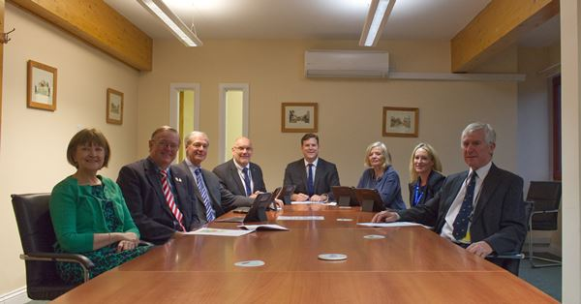

Climate focus for council cabinet following shake-up

Test Valley Borough Council (TVBC) has announced a new climate change chief to champion the authority’s green agenda at a leader’s decision day on Wednesday 27 October.

TVBC leader, councillor Phil North, has made various changes to his cabinet and while none of the councillors at the top table will change, their areas of focus will.

Crucially this will see the leader create a new portfolio – Climate Emergency and Countryside – headed up by councillor Alison Johnston.

Phil North, said: “With COP26 rapidly approaching, climate change is very much at the forefront of people’s minds. The scale of the task ahead – protecting the future of our planet and the lives of our children and all those who come after us – is the greatest challenge we will ever face. And the clock is ticking.

“Creating the Climate Emergency and Countryside portfolio reinforces our commitment to tackling climate change and enhancing the local environment. Since declaring a climate emergency in 2019, we have already increased our electric vehicle fleet, reduced our printing by hundreds of thousands of pages, and switched to an electricity tariff that uses renewable energy. But this is just the beginning and I look forward to councillor Johnston helping to drive forward this work for the council.”

Alison Johnston, added: “This is a huge area of work and there is undoubtedly a massive challenge ahead. But I am very much looking forward to getting stuck in and ensuring that we are doing all we can in Test Valley to slash our CO2 emissions and support the national and global fight against climate change.”

In further changes, deputy leader, councillor Nick Adams-King, will head up a portfolio on Recycling, Street Cleaning and Transport – tasked with delivering a major package of recycling reforms. This follows on from the authority previously pledging to give residents the chance to recycle glass, thin plastics (pots, tubs and trays) and Tetra Pak-style cartons in the same household recycling bin, as well as providing a weekly food waste service.

Community, Leisure and Tourism will sit with councillor David Drew, and councillor Ian Jeffrey will pick up Democracy and Governance.

Housing and Environmental Health, including diversity and inclusion, will now sit with councillor Tracey Tasker and the Planning portfolio will go to councillor Phil Bundy.

Councillor Maureen Flood will continue to look after Finance and Resources.

The leader and deputy leader will also continue to oversee strategic regeneration and partnerships in the north and south of the borough respectively.

iPad Loan Scheme



Women’s Night Safety toolkit
The Women’s Night Safety toolkit is produced by the Police and has been delivered to all licensed premises via their licensing team. However, it can be used by any organisation who welcome the public.
Download a copy here.

Councillor Ian Jeffrey cllrijeffrey@testvalley.gov.uk 01794 388872
Councillor Alison Johnston cllrajohnston@testvalley.gov.uk 01794 500610
Councillor Tony Ward cllrtward@testvalley.gov.uk 01794 389649

